MYRTLE BEACH CORVETTE CLUB

P.O. Box 4836

North Myrtle Beach SC 29597

[**www.myrtlebeachcorvetteclub.com**](http://www.myrtlebeachcorvetteclub.com/)

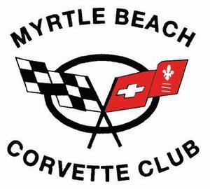

Membership Application

Type of New Membership: Single ($50.00) or Family ($80.00)

Family membership shall be defined as a husband and wife, or significant other of whom will have one equal and separate vote each.

If joining in the months of October, November or December, please add an additional $7.50 which will include the following year.

(Renewal Fee is $40.00 for a single and $60.00 for a family membership).

**Name (1)** Preferred First Name on badge **Name (2)** Preferred First Name on badge

**Address**

Birthday: Month/Day (1) Month/Day (2) Anniversary Home Phone Cell Phone (1) Cell Phone (2) Email (1) Email (2) Corvette Info: Year Body Style (Coupe or Convertible)

Color Model (Z51, Z06, ZR1 etc.)

Do you own other Corvettes? Any special talent(s) you have that you feel would benefit the club?

Would you be interested in holding an office or volunteering for the club?

As per our by-laws, all members must be 21 years of age and own a Corvette. A prospective member shall present an application and appropriate dues to the Membership Director. We hope all club members participate in as many club functions as possible and donate their time and talents for the betterment of the club.

Signed Date